**Key Features**

PRO Plus

Series

256GB

Capacity

180MB/s Read Speed

130MB/s Write Speed

• Our best-in-class read & write speeds up to 180MB/s & 130MB/s respectively.  
  
• UHS-I Speed Class 3 (U3), Class 10 and V30 for 4K UHD and FHD video with capacity up to 64GB.

Model

**PRO Plus + Reader Full Size SDXC**

$19.99$43.99

**Save $24.00**

**PRO Plus Full Size SDXC**

$29.99$35.99

**Save $6.00**

Storage

**128GB**

$17.99$21.99

**Save $4.00**

**256GB**

$29.99$35.99

**Save $6.00**

**64GB**

$14.99$16.99

**Save $2.00**

**512GB**

$39.99$65.99

**Save $26.00**

**VIP Advantage**

**VIP Advantage membershipLearn more**

* 2 Year Samsung Care+ (without Theft and Loss)
* Exclusive Discounts & Early Access

To select this option, please sign in or create a Samsung account

**Premium Benefits**

**$149.99/yr**

**Delivery & professional services**

Availability for:

96928

Delivery

**Delivery**

Not available



**In-Store Pickup**

Not available

This product is currently not available in your area.

**Choose your purchase option**

iconQuestions? Ask a Financing Expert

**One-time Payment**

**$29.99**

**Pay in 4 Installments**

**$7.50**

**every two weeks σπ**

**One-time payment**

Pay with your credit card, debit card or a pay app. Excludes taxes and shipping.

**PRO Plus Full Size SDXC Card 256GB$29.99**

**Total**

**$29.99 $35.99**

**You Saved Today$6.00**



**Log in now to earn up to 1.5% back in Samsung Rewards Points**

**Add to cart**

[**Where to buy**](https://www.samsung.com/us/computing/memory-storage/memory-cards/pro-plus-full-size-sdxc-card-256gb-mb-sd256s-am-buy)

Supported payment types:

adyen_cardsPayPal Venmo Checkoutamazonpaygooglepay



**PRO Approved**

Built to last, Samsung's PRO Plus offers extreme performance in a variety of capacities, with robust reliability making this SD card the ideal choice for photographers and other digital media professionals. Use it across your work devices, and continue relying on the #1 brand name in flash memory.¹

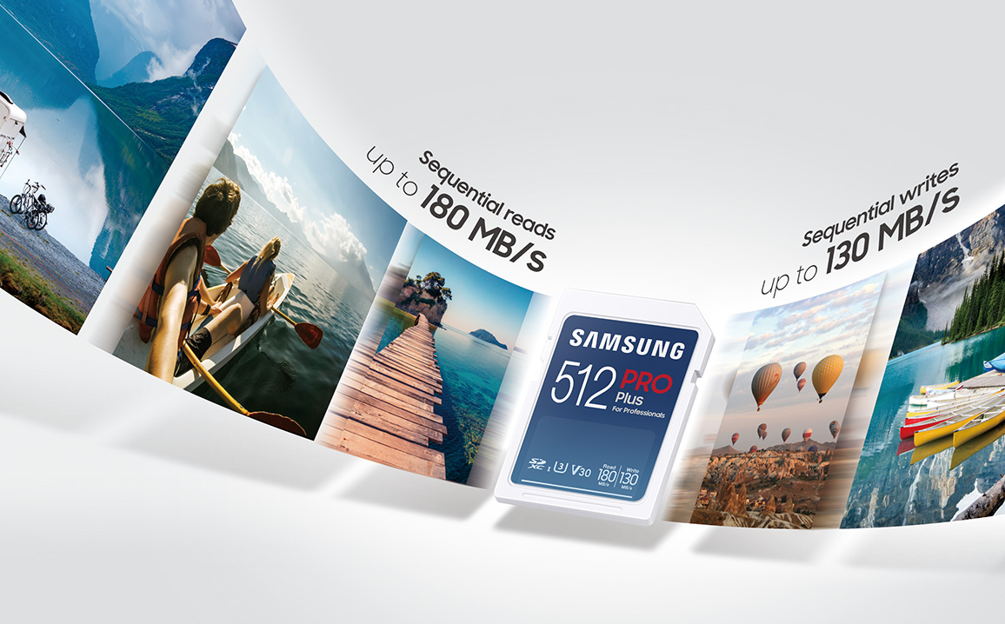

**Extreme speed**

A top choice for the pros. Extremely fast read/write speeds of 180MB/s and